2020 DDA DANCE RECITAL
Dancing Around The World
May 3, 16 & 17
1:00pm (Eastern) Company Pre-Show
2:15pm Recital
Eastern Pulaski High School Auditorium
715 School Drive, Winamac

First and foremost, THANK YOU for enrolling your child at our Dance Studio. We love what we do and hope your child loves dance as much as we do. Here is all of the information you will need for our three recitals. If you have any questions or concerns please let us know.

Inside this packet you will find:
- Rehearsal Information
- Recital Information
- How to order tickets
- Photo Order Form
- DVD Order Form
- Flower Order Form

Saturday, May 2nd – Rehearsal
All Student Full Dress Rehearsal at Winamac High School Auditorium
*Hair and Make Up Must be done- We plan to shoot our Recital DVD
during the rehearsal.
Arrival Time for all students is 12:00

*Arrive with full hair and make up done for your first dance. Once you arrive, go to the library to put on your costume and stay in that room until we come get you. You are NOT allowed to roam the hallways; parents need to stay with their dancer until we are ready to begin.
Be sure to have all dance shoes, socks, undergarments needed.
Rehearsal is mandatory, if you do not attend then you will not be allowed to participate in the recital on Sunday, May 3rd.
Please leave your costume hanging up in the library before you leave.
We will steam any costume that is in need. You will take them home after the recital on Sunday, May 3rd.
For our May 16th Recital you will bring your costumes with you that day and leave them overnight for the 17th show.

We do not know how long rehearsal will last for each dancer. This year we will be taping our recital DVD during the rehearsal, if things run smoothly then most dancers should be done in less than two hours.
Company dancers and dancers in the larger group routines (Ms. Ana’s) will stay longer than that. Company should plan to be there atleast 4 hours. Parents will be allowed to get them lunch.
Bring make-up with you for touch ups if needed.

Recitals
May 3, 16 & May 17
Company Dancers Pre- Show 1:00 pm
Recital – 2:15pm
This year we have decided to showcase our Company’s Competition Routines during a 50-minute Pre-Show. You will have the option to watch the entire show or just arrive for the recital portion of the show.
Younger dancers (6 & under) performing in the recital at 2:15 can sit on your lap and will be allowed to watch the Company Pre-Show, or we will have parents available in the library to watch them. If you do not wish to watch the Pre-Show, you have the option to arrive to the venue at 1:50 to get your dancer ready.
You will need to let us know beforehand which option you are choosing.
Older dancers ages 7 and up, that are not in the Pre-Show can also watch, we will have a special section of chairs reserved just for them.

*Company Dancers that are performing in the Pre-Show should arrive at 12:30 and immediately get into their first costume.

The same rules apply from above. Come with Hair & Make Up Done.
No Food is allowed in the library or auditorium, water bottles only to drink. If your dancer needs a snack for the rehearsal only, they must eat that in the hallway where there is no carpet. Please make sure it is nothing that will stain their costume or their faces.

Additional Rules:

- No Males are allowed into the Library/Changing Area
- You will need to sign in your dancer at our sign in table in front of the library. After the recital you will also need to sign them out.
- NO FOOD is allowed in the auditorium or library. Students can bring a water bottle (no other types of drinks are allowed) to the recital. Please have your child eat before arriving.
- Parents: (Not the dancers or Instructors) are responsible for the care of your child’s costumes. Please neatly hang up their costumes and put everything back into their costume bags. Along with their hair accessories, tights, shoes and take any hair and make up bags home with you.
- No Fingernail or Toe Nail Polish. No earrings, unless you just got them pierced.
- Please stress to all family and friends that we would like everyone to stay for the entire show. Even though your dancer might be done performing the other dancers would appreciate a large audience too. The Pre- Show & Recital should last about 2 + hours. There is NO LEAVING the auditorium until intermission unless you have an emergency or a child having a meltdown. It is very distracting and disrespectful to the dancers and the rest of the audience.
- Pre-Company & Company Parents will be required to help take tickets at the door, help with raffle ticket sales, handing out programs, help in changing area, working backstage, etc.
You will be assigned a specific job.

This year, we’re working with a company called TutuTix to make it easier for you to purchase recital tickets. Gone are the days of coming down to the studio, waiting in line, and spending your valuable time purchasing tickets, or trying to NOW, you’ll be able to do it from the convenience of your own living room, office, or wherever you are.

Tickets will go “on sale” at this date and time:
March 8 at 1:00 Eastern Time
At that time, you can purchase tickets by any of the following ways:
- Go to our special TutuTix page on your computer, tablet, or smart phone at www.tututix.com/dancedevelopmentacademy/
- Or call 855-222-2TIX (2849)
Ticket prices will be: $10
Children 5 and under that can sit on your lap for the entire show are free and do not need a seat. If they would like their own seat then they need to purchase a ticket.
Parents will need a ticket for every show that you wish to watch. It is mandatory for all dancers to do all three recitals but parents are not required to watch all three. You may sign your dancer in to the backstage helpers and pick them back up after the recital is over. You will not be allowed to stay in the hallway or watch from backstage, we need to keep this area cleared. And you will not be allowed to enter the auditorium at any time without a ticket.
Note that you will need a credit or debit card to buy tickets, and that tickets will be sold on a first come, first served basis. So, buy early to get better seats!

TutuTix charges a low, fair fee for their service. You’ll see their $1 per ticket fee, plus 5% processing charge added to your order at checkout.

You’ll have several options for how you want your ticket delivered. You can have it emailed to you, sent to your mobile phone internet browser, and even add it to your Apple Passbook (if you have the latest iPhone software) at no charge! Or, you can choose to have TutuTix mail you foil-embossed keepsake tickets for an additional fee– with your dancer’s name printed directly on the ticket!

We know this is a new process for us, that comes with additional fees.
Please keep in mind that over the past five years we have chosen to keep our recital ticketing price the same and lower than most local dance studios (usually $15 to $20) to show our appreciation to our dance families. Dancers unlike other sports only get to show off their hard work only a few times out of their dance year, so we hope you understand all of the time and hard work that it takes to put on our year end recitals.

Hair & Make Up:
Mini Company Dancers: will do competition make up (the only variation will be anyone with red lipstick will instead use the pink color and no glitter eyeliner)
Ms. Lili Dancers: will wear the same make up as the Mini Competition Dancers. There is a make-up list attached, along with how to apply. The colors are more natural this year. All dancers unless otherwise told will be wearing their hair up in a high bun.
Except for her hip-hop class, hair will be worn down.
Ms. Ana Dancers: Will wear competition make up except the glitter eyeliner and fake lashes. Recital Hair: Either low ponytail or bun, we will let you know soon. All Company Dancers will wear their competition hair styles for the Pre-Show portion of the show and then change for the recital.
Recital Dance Photos: March 30 – April 3.
Full Recital Hair & Make Up (No fingernail or toe nail polish should be worn or earrings) Please arrive at our studio with hair and make up done, you can change into your costume at the studio.
Once your group is ready, we will walk over to Melissa Tanner Photography Studio. Dance shoes cannot be worn outside, so be sure to have a different pair of shoes with you. With our younger dancers we will try to do their group shots first then move on to individual photos. After your photo shoot, please return to the studio and put your costumes and accessories back in their garment bags and take them home with you. They will only take photos on this day and will not have their regular classes.
This year we have a lot of classes that are combined, we will be posting which days/times that you need to arrive. Some of you will have to come on a different day than your usual class day/time. The photographer added a flash drive option for dancers in multiple dances, normally this was just reserved for Company Members but it is now available for All Dancers.
*Hip Hop Students – Be sure to bring black socks, & black high-top shoes.
*Girls needing undergarments: they have to be nude in color and no visible straps or panty lines.
*Day of the Dead – Girl dancers that are the “Boy Sugar Skulls” in the dance need a black tank top or leotard. The dancers that are “Girl Sugar Skulls” will need black short and nude color bras.
Recital Tickets: Tickets will go on sale March 8 and will continue until we sell out. There are only 334 seats available per show and in the past, we sold out both show in less than two weeks, this is why we added a third show. Please purchase your tickets as soon as possible to ensure that you get the seats you need.
Children who are 5 and under and can sit on your lap for the entire show are free and do not need to pay. Unless, they wish to have their own seat then they will need to purchase one.
Recital DVD: This year we will be video taping during rehearsal, that way we can get up closer to the dancers and not worry about getting in the way of any audience member.
Flowers for Dancers: It is customary for dancers to receive flowers after a performance. Country Color in Francesville provides a great service for our studio. Country Color will have your flowers waiting for you at the recital. You will pick up your flower order during after our Pre-Show and before the Recital start time. This is a great way to support another local business.
Other items available: The day of the recitals we will also have a limited amount of candy flower bouquets and other goodies for you or relatives to purchase for your dancer. There will also be different raffles baskets available too. Each dancer will receive a goodie bag in the entry way for them to take home as a thank you from us for all of their hard work this year.
Five Year Dance Awards: Last year was our 5th year in business and 4th recital. We were so happy to award numerous dancers with their 5-year dance award. This year we will be presenting the following dancers with their 5-year award: Mallory Howat, Kennedy Stalbaum, Julie Olds,
Addie Baker, Malachi Fitch, Emri Metzger, Alyvia Faler.
Congratulations Dancers!

Recital Flower Order Form

Place a check mark to indicate which recitals that you wish to order flowers for

May 3 May 16 May 17

Single Rose $5.00 _______ _______ _______

Small Bouquet $11.00 _______ _______ _______

Medium Bouquet $16.00 _______ _______ _______

Large Bouquet $21.00 _______ _______ _______

*Small Bouquets include daisies & carnations.
*Medium Bouquets include daisies, carnations & spider flowers
*Large Bouquets include the same as medium bouquets plus one rose.

Orders need to be turned in by April 17. Checks payable to Country Color
*You will pick up your flowers after the Pre-Show and before the Recital, we are not responsible for flower orders that are not picked up.

Dancer Name:_________________________________________________

Message for Dancer: (whatever you write will be transferred to a flower card, so please limit how much text you use and be sure to include who it was from.)

__________________________________________________________________

__________________________________________________________________

__________________________________________________________________

__________________________________________________________________

__________________________________________________________________

Dance Development Academy
2020 RECITAL DVD ORDER FORM
$10.00 Each

DVD orders will be done out approximately
two weeks after our 1st recital.

Student Name: ___________________________________

Qty Ordered: ____________________________________

We can also ship the DVD’s directly to you add $5.00 for Shipping Cost

DVD: $___________________________
Shipping: $________________________
Total: $___________________________

Mailing Address if applicable:
________________________________________________________

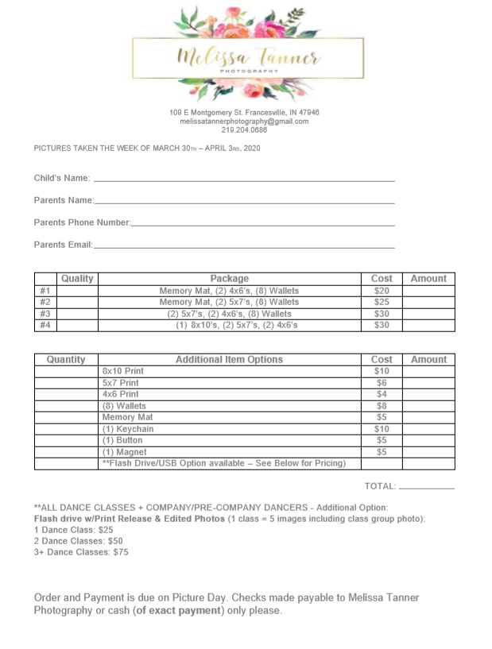
*The Memory Mat is a photo of the entire group of dancers in one routine

Make Up & Hair
Ms. Ana’s Classes: Most dancers should have this make up from last year’s recital.
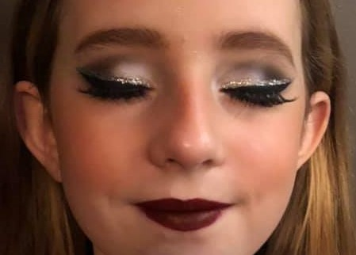
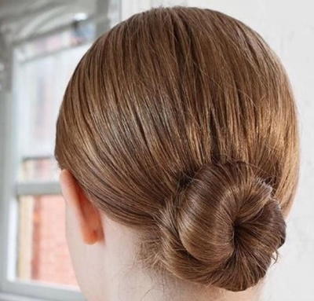

Eye Shadow: NYX Raven & Frostbite or if you have the black/white/silver trio previously used
Blush: E.L.F. Mellow Mauve
Lipstick: Loreal Infallible Pro-Matte Liquid – Color is “Stirred”
Eyeliner: Revlon Colorstay Skinny Liquid Black Eyeliner
Black Mascara – Any Kind
Lip stick appliques: Optional (but very useful)
Eyebrow pencil to match dancer’s hair color to fill in their brows. (optional)
*We are not using the silver glitter liner of fake lashes for recital.
Make Up & Hair
Ms. Lili’s Classes
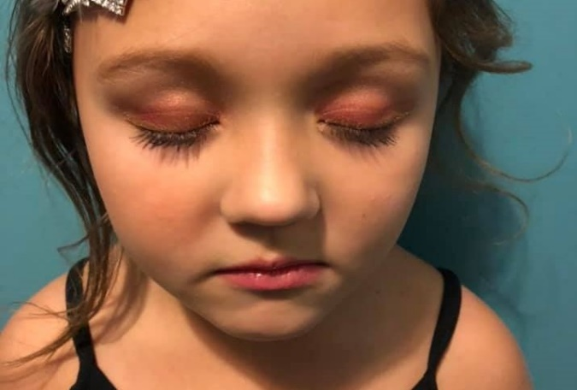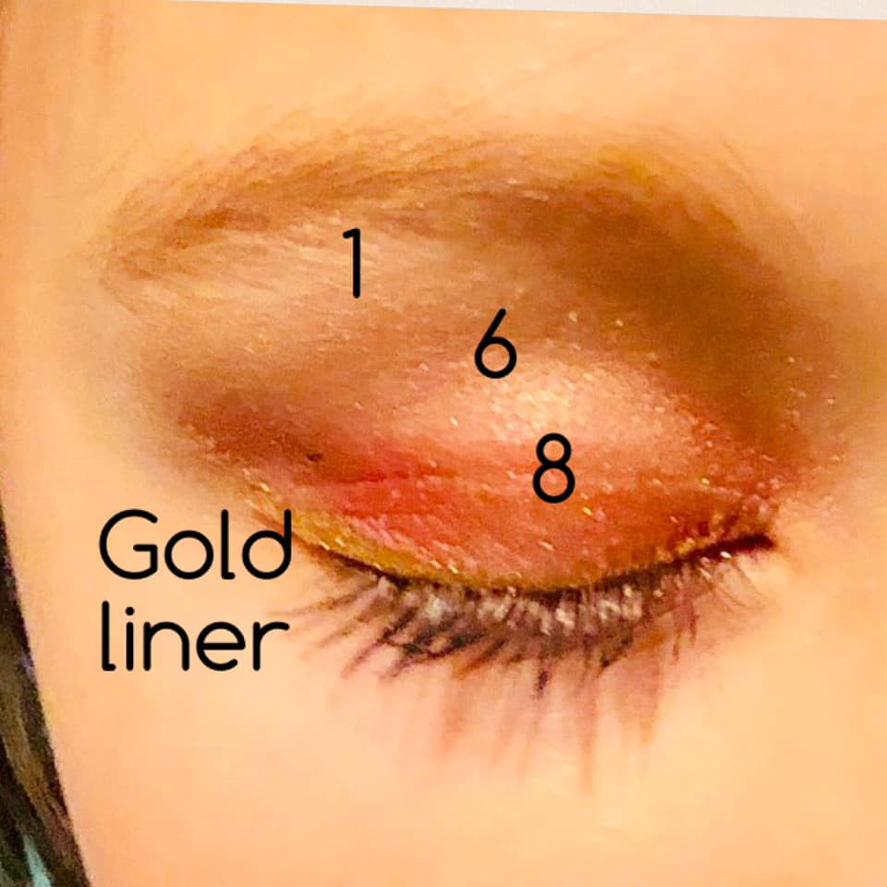
*We are not using the Gold Liner for recital
E.L.F. Rose Gold – Sunset Palette E.L.F. Mellow Mauve Blush

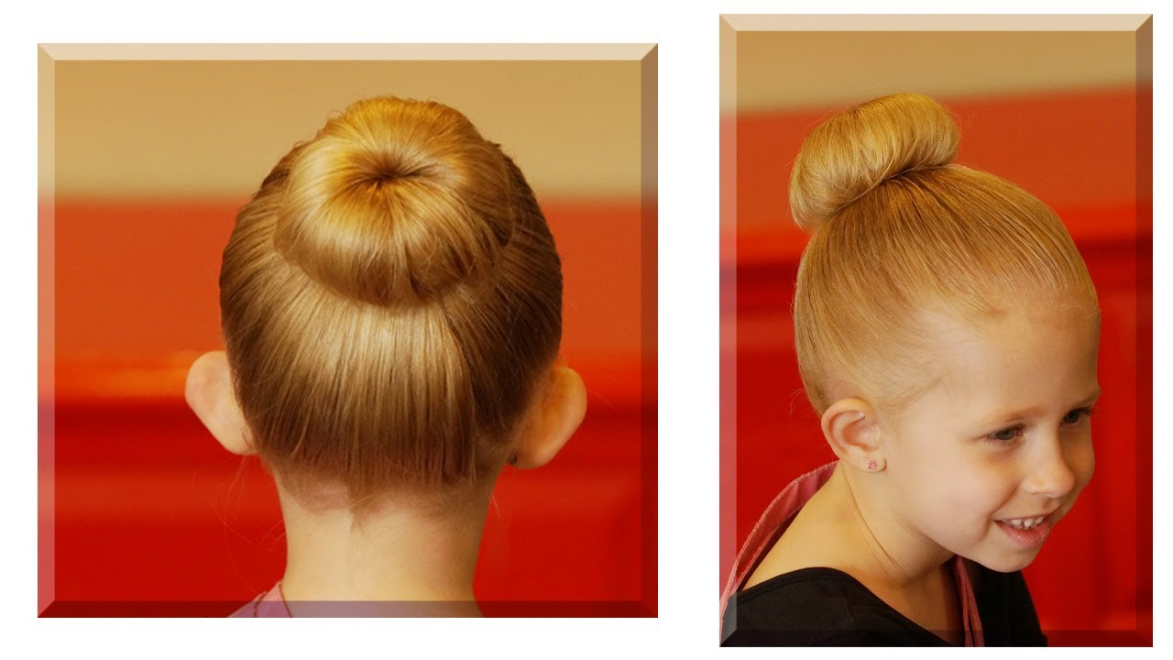
Rimmel Provocalips: Hair: High slick bun (be sure to watch the
Color: Wish Upon A Berry the bun tutorial and how to use a hair donut)
Black Mascara: Any Kind Those that are in Ms. Lili’s hip hop will take their
Eyebrow Pencil: optional bun out for that dance. If you are only in that
dance come with hair already down.
Photo Week Line Up
*day/time are subject to change
Monday, March 30:
Photo Order: Trio, Braylin, Abby, Maisie, Jordyn, Avi, Ashlin, Ethan & Bella Duet, Elizabeth, Kinzley, Bellamy, Gwen, Kylenn, Kaila, Mini Recital Group (The mini recital group is Kylenn, Kaila, Gwen, Elizabeth, Olivia, Bellamy & Kinzley) Older Group
Start time 4:15, we will go in this order to give those who live outside of town more time to get ready.
Tuesday, March 3:
Sammy Solo, Alyvia Solo, Ruth Solo, Kaylynn Solo, Zoey Solo, Brody & Ashlin Duet,
Emri Solo, Brody Solo(start time 4:15)
Ms. Ana’s Hip Hop & Contemporary Routines:
Alyvia, Brody, Sammy, Ashlin, Bella, Emri, Maisie, Jordyn, Avi, Abby, Braylin, Ruth, Emily, Kaylynn S., Ethan, Carson, Kaylynn K, Zoey, Kaylee K (please be at the studio and ready for photos by 5:00)
Wednesday, April 1
Bella’s Solo, Olivia Solo, (start time 4:30)
Princess Ballerinas: Jazmin, Lincoln, Paisley, Madison, Lucy, Alice, Amelia, Emerson, Finley, Terra (start time 5:00)
Dance Adventure: Via, Piper, Charlotte, Brynley, Annika (start time 5:45)
Hip Hop: Mirabel, Mira, Alexa, Olivia, Elizabeth (start time 6:15)
Thursday, April 2
Jazz: Gwen, Mallory, Temperance, Hazel, Maddy, Kennedy, Addie, Savannah, Everly G, (start time 5:00)
Malachi Solo (start time 5:30)
Tap – Mirabel, Kaylynn, Malachi (start time 5:30)
Ballet: Leyli, Hazel, Abigail, Charlotte M., Everly J., Zoey S., Macy, Temperance, Gwen, Maddy (start time 5:45)
Tap – Hazel, Abigail, Charlotte M., Everly J., Zoey S., Macy, Temperance, Gwen, Maddy (start time 5:45)
Hip Hop: Mallory, Hazel, Abigail, Everly J., Zoey S., Jia G., Temperance, Gwen, Maddy, Julia, Josie, Rae, Callie (start time 6:15)
*All dancers are required to attend the photo day, so we can display a group photo on our studio recital wall. We will have a paper at the studio for you to sign if you wish to purchase any individual dance photos. If you do not plan to purchase photo’s we will not have your dancer take any individual photos. They will only participate in the group shot. Once we know this information, we will be able to adjust arrival times if needed.

